UNITED  NATIONS |  | E
 | Economic and Social  Council | Distr.  GENERAL  ECE/TRANS/WP.29/GRSG/2010/XY  Original: ENGLISH

ECONOMIC COMMISSION FOR EUROPE

INLAND TRANSPORT COMMITTEE

World Forum for Harmonization of Vehicle Regulations (WP.29)

Working Party on General Safety Provisions (GRSG)

PROPOSAL FOR SUPPLEMENT TO GLOBAL TECHNICAL REGULATION CONCERNING
LOCATION, IDENTIFICATION AND OPERATION OF MOTORCYCLE CONTROLS, TELL-TALES AND INDICATORS

Include comments from Canada

This document is the update of document MCSYM-01-05 Annex 1 to bring it into line with the proposal for draft GTR document MCSYM-02-01 by inclusion of the operations as well as location and identification.

Please note that this document (MCSYM-02-02), issued separately, includes the list of symbols suggested by Members in additional to those included in document MCSYM-02-01. The intention of the informal group was that this document would be a supplement to document MCSYM-02-01.

COMMENTS TO INFORMAL GROUP SECRETARY BY 17 SEPTEMBER 2010
A. STATEMENT OF TECHNICAL RATIONALE AND JUSTIFICATION

I. INTRODUCTION

This proposed supplement to global technical regulation (gtr) on location, identification and operation of motorcycle controls, tell-tales and indicators determined to be critical for safety by GRSG Working Party. The objective of the proposal is to add to the current list of controls, tell-tales and indicators to reduce the safety hazards caused by driver distraction.

Specifically, the proposal is intended to reduce distractions resulting from an error in control selection or inconsistency in graphical representations of commands from one vehicle to another.

One of the main purposes of this proposal is to standardize and harmonize symbols identifying controls, tell-tales and indicators. It is expected that with standardization, symbol awareness and recognition would become straightforward for the travelling public. A clear advantage of symbols, or pictograms, over wording is that symbols overcome language barriers. Travellers must be able to operate motorcycles safely, even if they cannot understand the language of the country they are visiting. Recognition that is independent of language is necessary in a global motorcycle market.

Furthermore, some Contracting Parties are jurisdictions where there is more than one official language. In many of those jurisdictions, vehicle safety information must be presented in all official languages. This could result in a requirement to provide a language selection function to drivers or a means to display wording in all official languages, which would be difficult on space-limited dash panels.

Symbols are an efficient way of communicating information to drivers. The consistent use of a selected symbol in all new motorcycles would increase its recognition. Symbols have the potential to reduce driver confusion and simplify vehicle design. The symbol approach is also likely to be beneficial to those whose vision is poor, as symbols are easier to read than equivalent text.

The symbols set chosen in this global technical regulation is based on the ISO 6727 standard of the International Organization for Standardization (ISO).
B. TEXT OF THE REGULATION

1. SCOPE AND PURPOSE

This supplement to the global technical regulation specifies requirements for further location, identification and operation of motorcycle controls, tell-tales and indicators. The purpose of this supplement to the global technical regulation is to ensure the accessibility, visibility, and recognition of motorcycle controls, tell-tales, and indicators and to facilitate the proper selection of controls under daylight and night-time conditions. The global technical regulation intention is also to reduce the safety hazards that would otherwise be caused by the diversion of the rider's attention from the driving task by mistakes in selecting controls.

2. Application

This supplement to global technical regulation applies to power-driven vehicles of category 3.

3. DEFINITIONS

For the purpose of this supplement the definitions in the global technical regulation apply.

4. Requirements

These shall comply with clause 4 of the GTR.

Table 1. Symbols identifying controls, tell-tales and indicators

No. | Column 1 | Column 2 | Column 3 | Column 4 | Column 5 | Column 6 | Column 7 | Column 8
 | ITEM | WORDS | SYMBOL | FUNCTION | LOCATION | COLOUR | DEFINITION | OPERATION
29 | Antilock brake system  malfunction |  |  | Tell-tale |  | Yellow
30 | Brake system malfunction |  |  | Tell-tale |  | Red
31 | Engine on-board diagnostics  or engine malfunction |  | 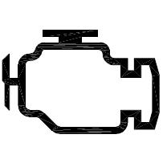 | Tell-tale |  | Yellow
32 | Engine oil temperature |  | 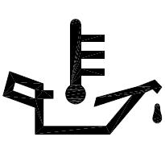 | Indicator
 |  |  |  | Tell-tale |  | Red

No. | Column 1 | Column 2 | Column 3 | Column 4 | Column 5 | Column 6 | Column 7 | Column 8
 | ITEM | WORDS | SYMBOL | FUNCTION | LOCATION | COLOUR | DEFINITION | OPERATION
23 | Automatic vehicle speed system (cruise control) |  | 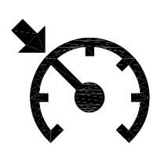 | Control
23 | Automatic vehicle speed system (cruise control) |  |  | Tell-Tales |  | Green
33 | Low tyre pressure |  | 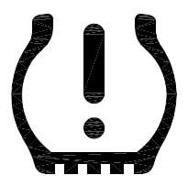
33 | Low tyre pressure |  |  | Tell-Tales |  | Yellow
34 | Service reminder |  | 
34 | Service reminder |  |  | Tell-Tales |  | Yellow

No. | Column 1 | Column 2 | Column 3 | Column 4 | Column 5 | Column 6 | Column 7 | Column 8
 | ITEM | WORDS | SYMBOL | FUNCTION | LOCATION | COLOUR | DEFINITION | OPERATION
11 | Optical warning device |  | 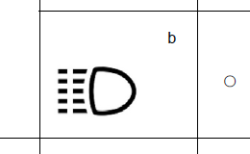 | Tell-tale |  |  | China GB15365 (2008) uses the icon from draft ISO 7000
35 | Stands |  |  | Control |  |  |  | A stand shall fold rearward and upward if it contacts the ground when the motorcycle is moving forward. This requirement does not apply to motor tricycles.
36 | DRL |  |  | Tell-tale |  | Green

